Project Planning Phase
Project Planning Template (Product Backlog, Sprint Planning, Stories, Story points)

Date | 18 October 2026
Team ID | NEHAL YADAV
Project Name | FORMULA 1 Race Intelligence Dashboard Analysis Report 2010-2026
Maximum Marks | 8 Marks

Product Backlog, Sprint Schedule, and Estimation (4 Marks)
Use the below template to create product backlog and sprint schedule
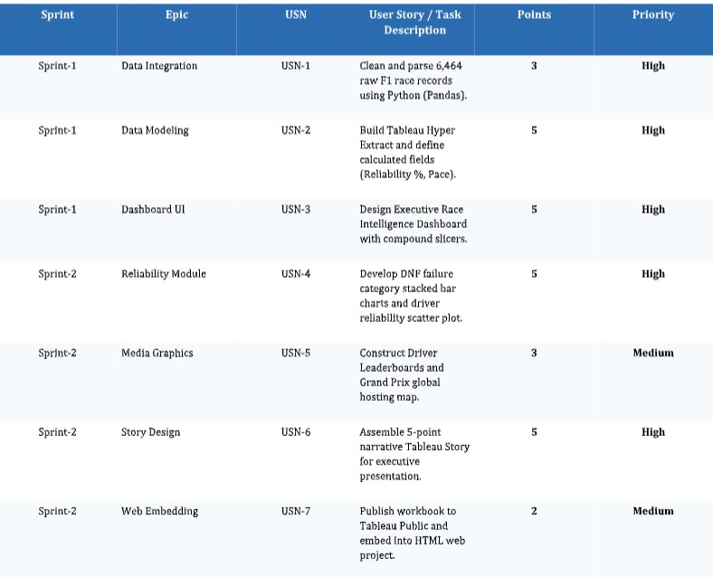

Project Tracker, Velocity & Burndown Chart: (4 Marks)
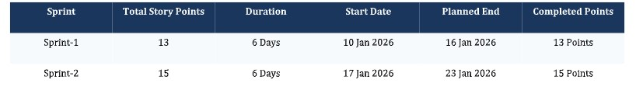
Team Velocity Calculation:
Velocity = Total Completed Points / Sprint Duration = 28 Story Points / 12 Days = 2.33 Story Points / Day.
Burndown Chart:
A burn down chart is a graphical representation of work left to do versus time. It is often used in agile software development methodologies such as Scrum. However, burn down charts can be applied to any project containing measurable progress over time.

https://www.visual-paradigm.com/scrum/scrum-burndown-chart/
https://www.atlassian.com/agile/tutorials/burndown-charts

Reference:
https://www.atlassian.com/agile/project-management
https://www.atlassian.com/agile/tutorials/how-to-do-scrum-with-jira-software
https://www.atlassian.com/agile/tutorials/epics
https://www.atlassian.com/agile/tutorials/sprints
https://www.atlassian.com/agile/project-management/estimation
https://www.atlassian.com/agile/tutorials/burndown-charts

